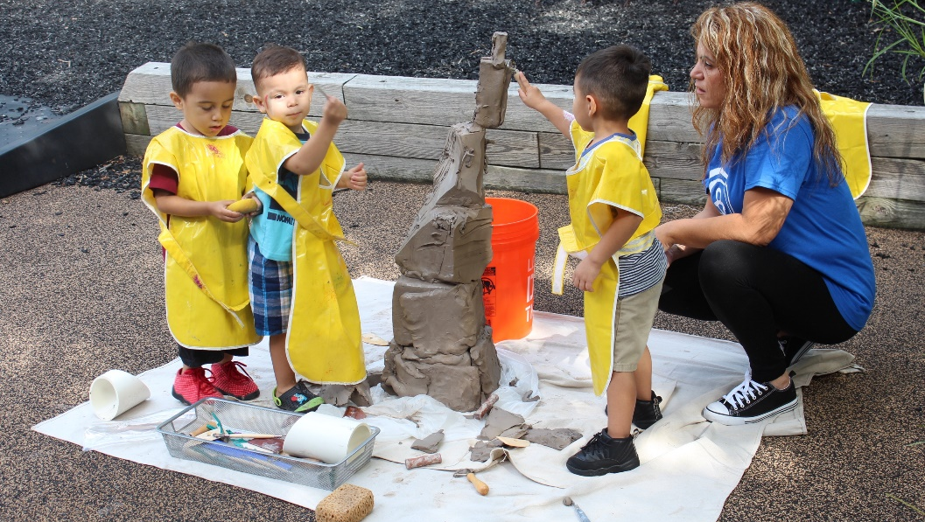
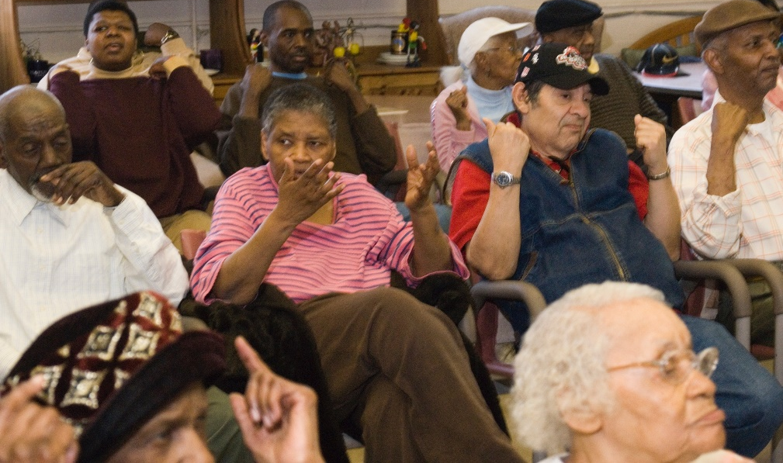
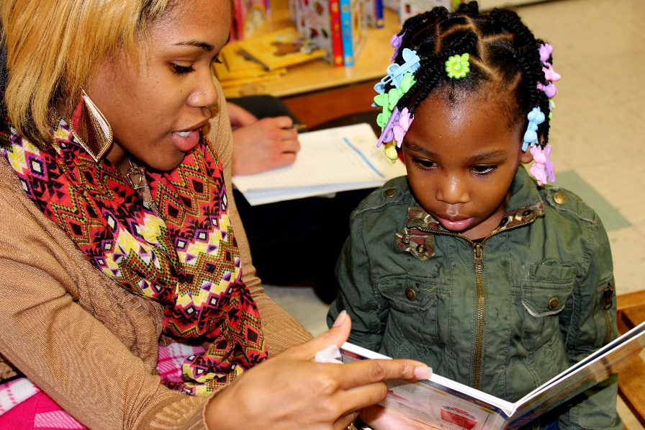

Generations of Generosity
125 years of Chicago Commons
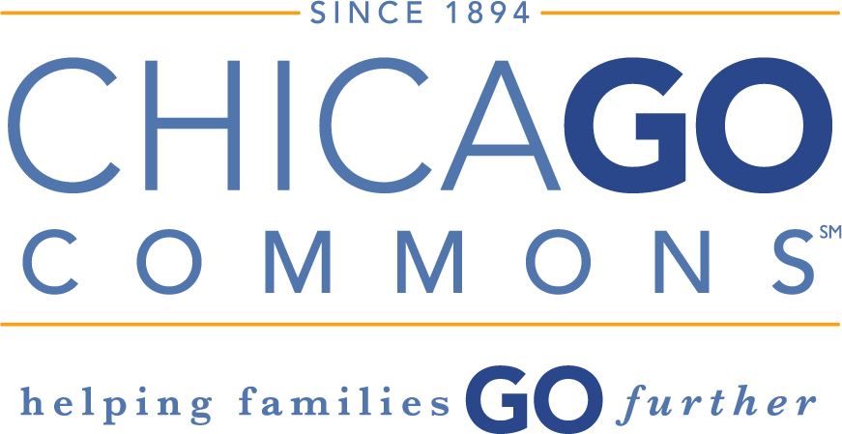

Sponsorship Opportunities

CONTACT:

Cheryl Wisniewski
Director of Annual Giving
773-826-4256
WisniewskiC@ChicagoCommons.org

Mary Penn
Director of Corporate and Foundation Relations
773-332-1862
PennM@ChicagoCommons.org

Generations of Generosity
125 years of Chicago Commons

Our History
Founded by Graham Taylor in 1894, Chicago Commons is celebrating its 125th anniversary in 2019! Chicago Commons was one of the original settlement houses primarily serving immigrants on the city’s northwest side. As a way of encouraging community and building opportunities for the neighborhood’s residents, Chicago Commons opened one of the city’s earliest kindergartens in 1897. Soon after, Commons began to offer programs for individuals of all ages through clubs and classes, and provided
an open forum for discussion of local community events.

Today, Chicago Commons maintains the values of the historic Settlement House Movement by continually engaging in dialogue with community residents. We base our strategic direction on listening to the people we serve, understanding how the neighborhoods around us are changing, and seeking innovative ways to respond.

Our Programs
Chicago Commons serves some of the city’s most under-resourced communities on the south and west sides through early childhood education, family engagement, and senior services.

Our comprehensive early childhood education program was among the first in the nation to systematically implement the principles of the Reggio Emilia approach with children from under-resourced communities, earning us national attention. Commons’ four early education centers in Humboldt Park, Pilsen, and Back of the Yards serve children from birth to age five. We also provide professional development training, supportive staff, and evaluation to 10 other early education providers across Chicago through our Community Partner Program.

The Family Hub meets the unique needs of both the child and parent/caregiver(s) by empowering families with the tools they need to realize their ambitions. We provide one-on-one coaching, referrals, and access to resources. Each early education center serves as a hub of support for the entire family with programing that includes educational attainment, job readiness and job search assistance, financial literacy, digital skill-building, and health/wellness workshops.

Chicago Commons’ senior services include both Adult Day Services (ADS) and Home Care. These programs are designed to help seniors and adults with disabilities stay in their homes, maintaining their independence and quality of life. Our ADS program is a professional care setting in which clients are transported to our center to receive individualized care in a community-based group setting. Our Home Care program service aides support seniors’ independence in their own home.

OUR IMPACT
Each year, the agency serves more than 3,000 individuals directly and touches the lives of over 10,000 Chicagoans.
We prepare 1,200 preschool children for elementary school and lifelong success at our four early childhood education sites and Community Partner sites.
Nearly 1,500 seniors and adults with disabilities are served in our Adult Day Care or receive daily or weekly Home Care to provide support, discuss challenges, and bring useful resources.

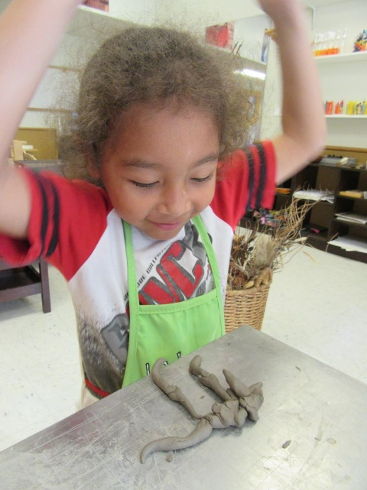

Generations of Generosity
125th Anniversary Celebration
Friday, November 15th, 2019
5:30-11:00 p.m.
Radisson Blu Aqua Chicago, Atlantic Ballroom

SPONSORSHIP BENEFITS | Union St. Sponsor  $50,000 | Grand Ave. Sponsor  $25,000 | Emerson  Sponsor  $15,000 | Taylor Sponsor  $10,000 | Robinson Sponsor  $5,000 | Friend of Commons  $3,000
One table (10 seats each) | Two Premiere | One Premiere | One Premiere
Welcome remarks from stage
Recognized sponsor of fall 2019 Lea Taylor Society Luncheon
Volunteer opportunity with Commons’ 2019 Senior Holiday Luncheon or other volunteer day
Recognition in 125th anniversary video project(s)
Logo featured on mobile bidding platform
Your company’s signage or banner onsite at event
Ad in program book
Dedicated social media mentions | 5 | 4 | 3 | 2 | 1
Recognized as sponsor of Pour Out Your Heart afterparty | Platinum | Platinum | Gold | Silver | Bronze
Onsite slide show listing | Logo | Logo | Logo | Logo | Logo | Name
Name or logo included on printed and electronic invitations | Logo | Logo | Logo | Logo | Logo | Name
Recognition in annual report, website, and newsletter

Generations of Generosity
125th Anniversary Celebration
Friday, November 15th, 2019
5:30-11:00 p.m.
Radisson Blu Aqua Chicago, Atlantic Ballroom

Sponsorship commitment form
We would like to sponsor Chicago Commons’ 125th Anniversary Event:
☐ Union St. Sponsor $50,000
☐ Grand Ave. Sponsor $25,000
☐ Emerson Sponsor $15,000
☐ Taylor Sponsor $10,000
☐ Robinson Sponsor $5,000
☐ Friend of Commons $3,000
☐ We wish to purchase tickets: ____ x $300 each = $ Total
☐ We are unable to sponsor but wish to make a contribution of $_____
Registration Information
Company: Company
Contact Name and Title: Contact Name , Title
Address: Address City/State/Zip: City, State, Zip
Phone: Phone Email: Email
For sponsors $5,000 and up, please provide social media information:
Facebook page address: Facebook
Twitter handle: Twitter
Payment Information
Credit Card # Credit Card #
Expiration Date: 00/00 CVV: ___
Signature __________
☐ Check made out to Chicago Commons enclosed
Please return this form by: June 1 to have your company included on the Save the Date card; by September 6 to be included on the invitation; and by October 15 to be included in the program book.

Email to: Emma Walsh, WalshE@ChicagoCommons.org

Or Mail to: Chicago Commons, 515 E. 50th Street, Chicago IL 60615

For more information please contact: Cheryl Wisniewski, 773-826-4256 WisniewskiC@ChicagoCommons.org
Generations of Generosity
125th Anniversary Celebration
Friday, November 15th, 2019
5:30-11:00 p.m.
Radisson Blu Aqua Chicago, Atlantic Ballroom

Host Committee (in Formation)

Mary E. Timmons* Co-chair
Senior Vice President, Northern Trust
Dorothy Abreu*
Vice President, PNC Bank
Joan G. Adler
Former Chicago Commons Board Member
Mary Lou Anton
Former Chicago Commons program participant
Daniel Chavez*
Partner, PWC LLP
Willard S. Evans, Jr.*
Chairman of the Board of Directors,
Illinois Toll Highway Authority
Caroline Harney*
Attorney, University of Chicago Service League
Torrence Hinton*
Director Operations & Maintenance, Peoples Gas
James Hill III*
President, ICL, LLC
Ronald G. Kaminski*
CEO, HBK Engineering, LLC
Philip B. Kenny*
Senior Vice President, Construction Practice, Marsh

Brian Marquez*
Associate General Counsel, Tampico Beverages, Inc.
Kathryn Meagher
Civic Leader and student
Julio Paz
Chief Development Officer, Chicago Commons
Mary Penn
Director of Corporate and Foundation Relations, Chicago Commons
Edgar R. Ramirez*
President and CEO, Chicago Commons
Julie Sausen*
Senior Vice President, Northern Trust Company
Robert E. Smietana*
President and CEO, HSA Commercial Real Estate
Cheryl Wisniewski
Director of Annual Giving, Chicago Commons
Eric Woods
Director of Facilities and Procurement,
Chicago Commons

* Chicago Commons Board Member

125th Anniversary Auction and Pour Out Your Heart Committee
Chicago Commons Emerging Leaders Council

Jessica Bozek
Language Arts Teacher, School District 181
Megan Cage
Operations Analyst, Information Resources Inc.
Julia Clark
Gerontologist, Director of Health Partnerships,
Oak Street Health
Chelsey French
Sales Manager, Fairmont Chicago Millennium Park
Alex Kapustka
Senior Associate, PWC LLP
Jessica Maldonado
Permitting Coordinator, HBK Engineering
Katheryn Meagher
Civic leader and student
Sharon Moy
Project Specialist III, Peoples Gas
Allison Reisch
CRM and Database Marketing Manager, Vi Living
Ana Renteria
Estimates Coordinator, John Burns Construction
Tara Szwabowski
Assistant Secretary, John Burns Construction
Ashlyne Wilson
Corporate Communications Specialist, Options Clearing Corporation

Union St. Sponsors are offered field exclusivity in this category. History lesson! Sponsorship opportunities are named after Chicago Commons’ first five sites chronologically were Union Street in 1894, Grand Avenue in 1901, Emerson House in 1948, Taylor House in 1958, and Jackie Robinson House in 1965. Additional sites, in chronological order, were located in Old Town, Englewood, New City, Bridgeport, West Humboldt Park, Back of the Yards, and Bronzeville, several of which are current program sites.

